Meeting with Hardware Team and Payload Team - 2/11

Notes:

* Mission Planner is written in C++
* The search pass over the area of interest will run for approximately 8 minutes
* The camera, ADP servos, and the autopilot will be connected directly to the Raspberry Pi
* The Aircraft Design Team is not fixed on the imaging equipment, so talk to TA for camera options
* There is a $500 budget for the project, but consider talking with Prof Z. on allocating more funds

CONOPS GOALS

surveillance accuracy (ability to keep target in certer of surveillance circle, target in view during whole surveillance): 10 feet

delivery accuracry (how close ADP hits target): 10 feet

mapping accuracy (how accurate our map is): 15 feet

surveillance efficiency (how quickly we complete surveillance segment): 4 minutes

search efficiency (how quickly we complete search segment): 6 minutes

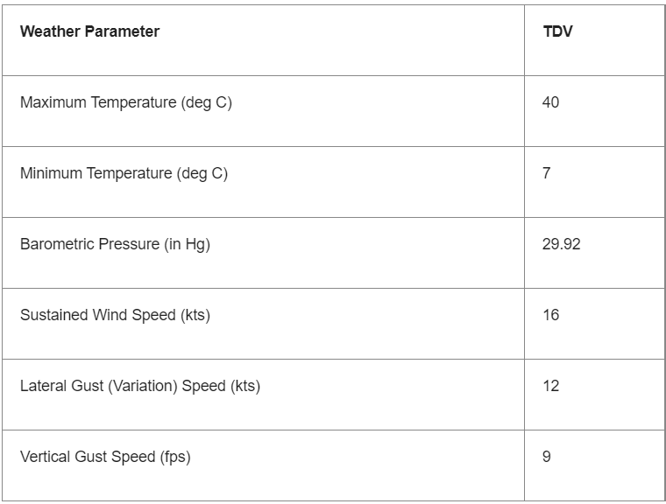

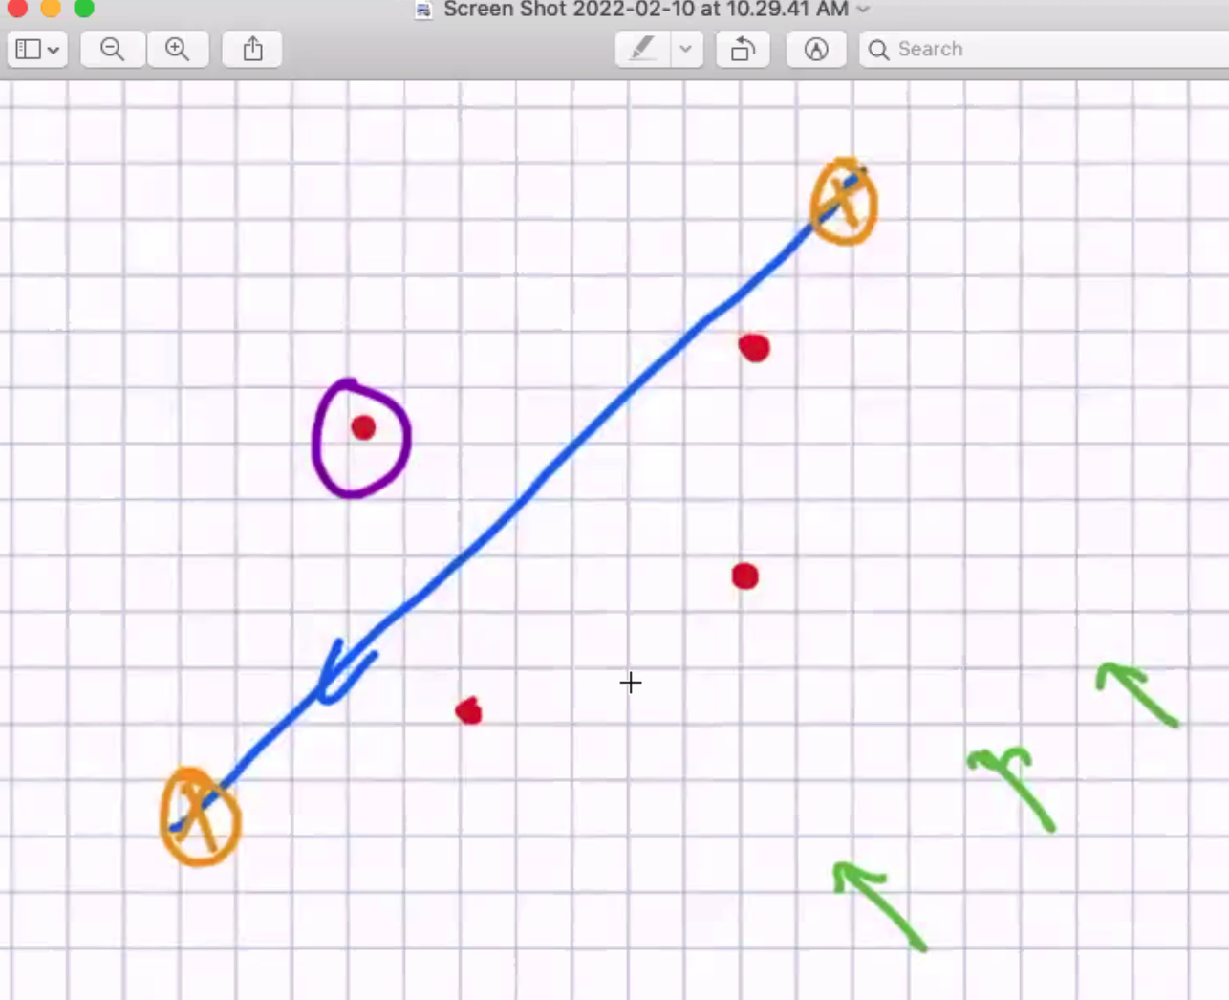

Questions/Concerns

* Talk to Mark (principal investigator of ASE labs); he knows a lot about the Mission Planner software; it would help to determine whether the coordinates from the GPS module can be send directly to the Autopilot as opposed to being sent from GPS module to the Mission Planner and then from the Mission Planner to the autopilot
* How will the imaging equipment be controlled during the pass over (what will the degree of freedom be of the images, how will we apply the Euler angles)

Next Steps

* Talk to Mark (principal investigator of ASE labs); he knows a lot about the Mission Planner software; it would help to determine whether the coordinates from the GPS module can be send directly to the Autopilot as opposed to being sent from GPS module to the Mission Planner and then from the Mission Planner to the autopilot
* Determine how will the imaging equipment be controlled during the pass over (what will the degree of freedom be of the images, how will we apply Euler angles to pre-process our image frames?)
* Alternatively, will the Payload drop team be determining how to position the imaging equipment and ultimately, how to apply Euler angles and filter the imagery based on crosswinds and other environmental factors
* Run through Mission Planner documentation